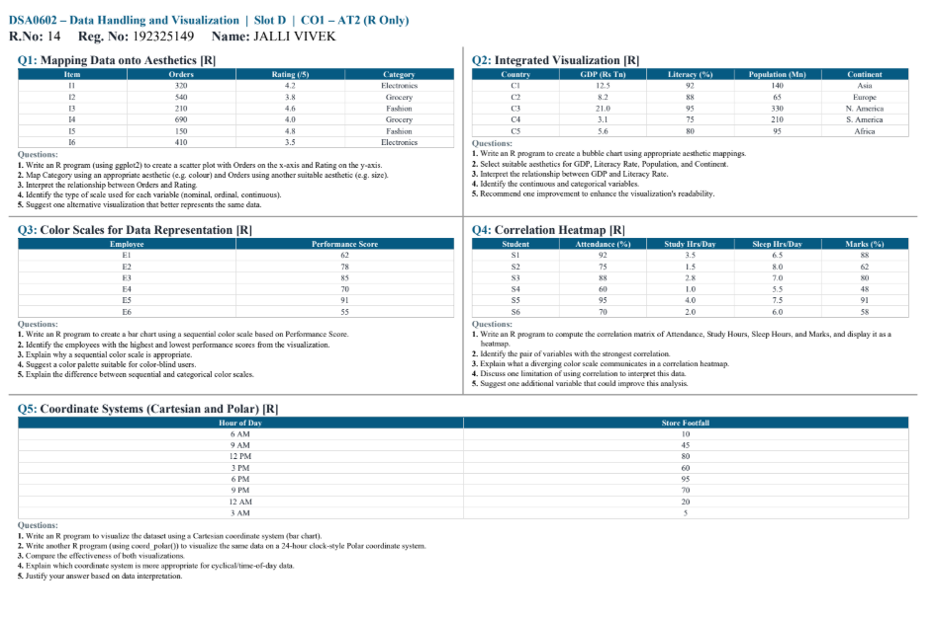

DSA0602 – Data Handling and Visualization
Slot D | CO1 – AT2 (R Only)
R.No: 14
Reg. No: 192325149
Name: JALLI VIVEK
Q1: Mapping Data onto Aesthetics [R]
Given data
Item | Orders | Rating | Category
I1 | 320 | 4.2 | Electronics
I2 | 540 | 3.8 | Grocery
I3 | 210 | 4.6 | Fashion
I4 | 690 | 4.0 | Grocery
I5 | 150 | 4.8 | Fashion
I6 | 410 | 3.5 | Electronics
1. R program for scatter plot
library(ggplot2)
data <- data.frame(
Item = c("I1","I2","I3","I4","I5","I6"),
Orders = c(320,540,210,690,150,410),
Rating = c(4.2,3.8,4.6,4.0,4.8,3.5),
Category = c("Electronics","Grocery","Fashion","Grocery","Fashion","Electronics")
)
ggplot(data, aes(x = Orders, y = Rating,
color = Category, size = Orders)) +
geom_point() +
labs(title = "Orders vs Rating",
x = "Orders",
y = "Rating")
2. Aesthetic mappings
- x-axis: Orders
- y-axis: Rating
- Color: Category
- Size: Orders
3. Relationship interpretation
There is a negative relationship between Orders and Rating. In general, items with higher orders tend to have lower ratings.
The correlation is approximately -0.70, indicating a moderately strong negative relationship.
4. Type of scale
- Orders: Continuous
- Rating: Continuous
- Category: Nominal
5. Additional aesthetic
Shape can be mapped to Category to further distinguish the product categories.

Q2: Integrated Visualization [R]
1. Bubble chart
library(ggplot2)
data <- data.frame(
Country = c("C1","C2","C3","C4","C5"),
GDP = c(12.5,8.2,2.0,3.1,5.6),
Literacy = c(92,88,95,75,90),
Population = c(140,65,330,210,95),
Continent = c("Asia","Europe","N. America","S. America","Africa")
)
ggplot(data, aes(x = GDP, y = Literacy,
size = Population, color = Continent)) +
geom_point(alpha = 0.7) +
labs(title = "GDP, Literacy and Population",
x = "GDP (Rs Tn)",
y = "Literacy (%)",
size = "Population (Mn)",
color = "Continent")
2. Suitable aesthetics
- GDP → x-axis
- Literacy → y-axis
- Population → bubble size
- Continent → color
3. Relationship between GDP and Literacy
There is a weak positive relationship between GDP and literacy in this dataset. However, the relationship is not very strong.
4. Identify continuous and categorical variables
Continuous:
- GDP
- Literacy
- Population
Categorical:
- Country
- Continent
5. Improvement for readability
Use a color-blind-friendly categorical palette and add country labels to the bubbles so that individual countries can be identified easily.

Q3: Color Scales for Data Representation [R]
Given data
Employee Performance Score
E1 62
E2 78
E3 85
E4 70
E5 91
E6 55
1. R program using sequential color scale
library(ggplot2)
data <- data.frame(
Employee = c("E1","E2","E3","E4","E5","E6"),
Performance = c(62,78,85,70,91,55)
)
ggplot(data, aes(x = Employee, y = Performance,
fill = Performance)) +
geom_col() +
scale_fill_gradient(low = "lightblue", high = "darkblue") +
labs(title = "Employee Performance",
x = "Employee",
y = "Performance Score")
2. Best color scheme
Use a light-to-dark sequential color scale, such as:
Light blue → medium blue → dark blue
Low scores are represented by lighter colors and high scores by darker colors.
3. Why sequential color scale is appropriate?
Performance score is a quantitative ordered variable. A sequential color scale clearly communicates increasing or decreasing magnitude.
4. Color palette suitable for color-blind users
A blue-based sequential palette is a good choice because it generally provides good distinction for many forms of color-vision deficiency.
5. Difference between sequential and categorical scales
Sequential scale:
Used for numerical values that progress from low to high.
Example: Performance Score.
Categorical scale:
Uses clearly different colors for separate categories.
Example: Continent, Category, Department.

Q4: Stacked Bar Charts and Proportions [R]
Data: Quarter = Q1, Q2, Q3, Q4; Brand P (%) = 35, 38, 42, 45; Brand Q (%) = 40, 36, 33, 30; Brand R (%) = 25, 26, 25, 25.
1. Write an R program to create a stacked bar chart showing each brand's market share (%) by Quarter.
library(ggplot2)

data <- data.frame(
Quarter = c("Q1", "Q2", "Q3", "Q4"),
P = c(35, 38, 42, 45),
Q = c(40, 36, 33, 30),
R = c(25, 26, 25, 25)
)

data_long <- data.frame(
Quarter = rep(data$Quarter, 3),
Brand = rep(c("Brand P", "Brand Q", "Brand R"), each = 4),
Share = c(data$P, data$Q, data$R)
)

ggplot(data_long, aes(x = Quarter, y = Share, fill = Brand)) +
geom_bar(stat = "identity") +
labs(title = "Market Share by Quarter",
x = "Quarter",
y = "Market Share (%)") +
theme_minimal()
2. Modify the program to create a 100% (proportional) stacked bar chart.
ggplot(data_long, aes(x = Quarter, y = Share, fill = Brand)) +
geom_bar(stat = "identity", position = "fill") +
scale_y_continuous(labels = scales::percent) +
labs(title = "Proportional Market Share by Quarter",
x = "Quarter",
y = "Market Share (%)") +
theme_minimal()
3. Compare what each version communicates about the brands' relative performance.
The normal stacked bar chart shows the actual market share values of each brand for every quarter.
The 100% proportional stacked bar chart focuses on the relative proportion of each brand within each quarter. Since every bar has the same total height, it makes it easier to compare the percentage contribution of each brand.
4. Identify the brand with a consistently rising trend.
Brand P has a consistently rising trend. Its market share increases from 35% in Q1 to 38% in Q2, 42% in Q3, and 45% in Q4.
5. Explain a limitation of stacked bar charts when comparing individual segment sizes.
A limitation is that it can be difficult to compare individual segments accurately, especially when they do not start from the same baseline. This makes small differences between some brands harder to identify.

Q5: Mapping Data onto Aesthetics [R]
Data: Item = I1, I2, I3, I4, I5, I6; Orders = 320, 540, 210, 690, 150, 410; Rating = 4.2, 3.8, 4.6, 4.0, 4.8, 3.5; Category = Electronics, Grocery, Fashion, Grocery, Fashion, Electronics.
1. Write an R program (using ggplot2) to create a scatter plot with Orders on the x-axis and Rating on the y-axis.
library(ggplot2)
data <- data.frame(
Item = c("I1", "I2", "I3", "I4", "I5", "I6"),
Orders = c(320, 540, 210, 690, 150, 410),
Rating = c(4.2, 3.8, 4.6, 4.0, 4.8, 3.5),
Category = c("Electronics", "Grocery", "Fashion",
"Grocery", "Fashion", "Electronics")
)
ggplot(data, aes(x = Orders, y = Rating)) +
geom_point() +
labs(title = "Orders vs Rating",
x = "Orders",
y = "Rating") +
theme_minimal()
2. Map Category using an appropriate aesthetic and Orders using another suitable aesthetic.
ggplot(data, aes(x = Orders, y = Rating,
color = Category, size = Orders)) +
geom_point(alpha = 0.8) +
labs(title = "Orders vs Rating by Category",
x = "Orders",
y = "Rating",
color = "Category",
size = "Orders") +
theme_minimal()
3. Interpret the relationship between Orders and Rating.
The data does not show a strong positive relationship between Orders and Rating. Items with a higher number of orders do not necessarily have higher ratings.
For example, I5 has only 150 orders but has the highest rating of 4.8, while I6 has 410 orders but has the lowest rating of 3.5. Therefore, the relationship between Orders and Rating appears weak or unclear in this small dataset.
4. Identify the type of scale used for each variable.
Orders – Continuous scale.
Rating – Continuous scale.
Category – Nominal scale.
Item – Nominal scale.
There is no ordinal variable in this dataset.
5. Suggest one alternative visualization that better represents the same data.
A grouped or faceted bar chart can be used to compare Ratings across individual Items and Categories more clearly. A box plot by Category is another suitable option if the purpose is to compare rating distributions between categories.

